Backpack Flashlight SMD

Bill of materials
Annotation | Value | Qty
C1,C2 | 4u7 | 2
D1 | 1206 Red low intensity | 1
D3,D4,D5,D6,D7,D8,D9,D10,D11,D12,D13,D14 | 1206 Red high intensity | 12
D2 | BAS70-06 | 1
J1 | 105017-0001 | 1
J2 | 6pin | 1
Q1 | BSS84 | 1
Q2 | BC848 | 1
R1 | 47k | 1
R2 | 470R | 1
R3 | 2M2 | 1
R4,R5,R6,R19,R20 | 10k | 5
R7,R8,R9,R10,R11,R12,R13,R14,R15,R16,R17,R18 | 220R | 12
SW1 | 6x6 SMD | 1
TP1 | BAT+ | 1
TP2 | BAT- | 1
U1 | MCP73831-2-OT | 1
U2 | ATtiny24-20SS | 1

PCB assembly
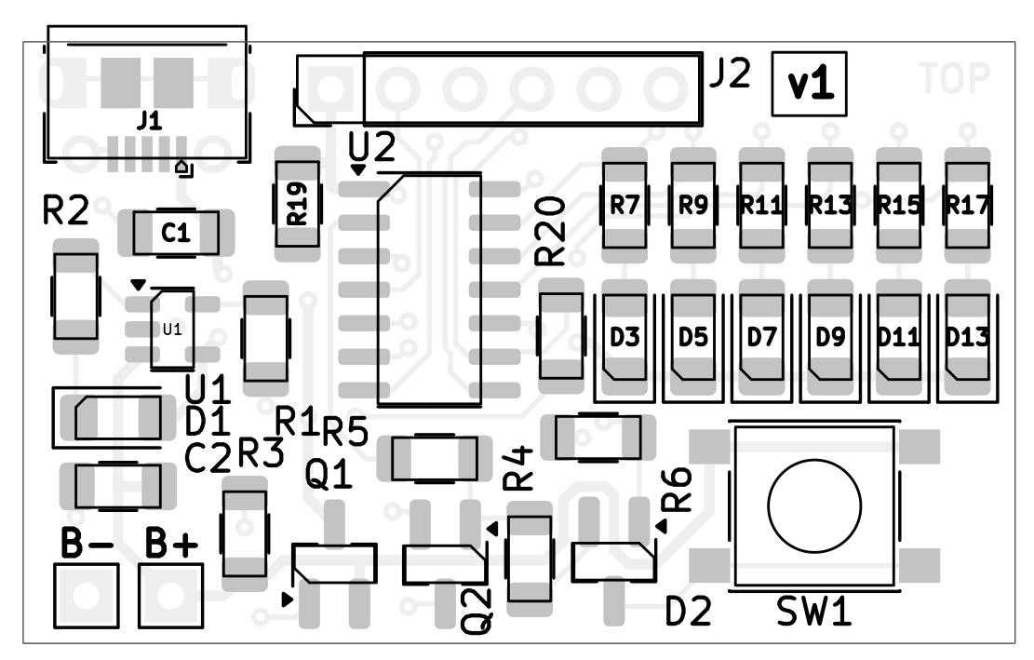
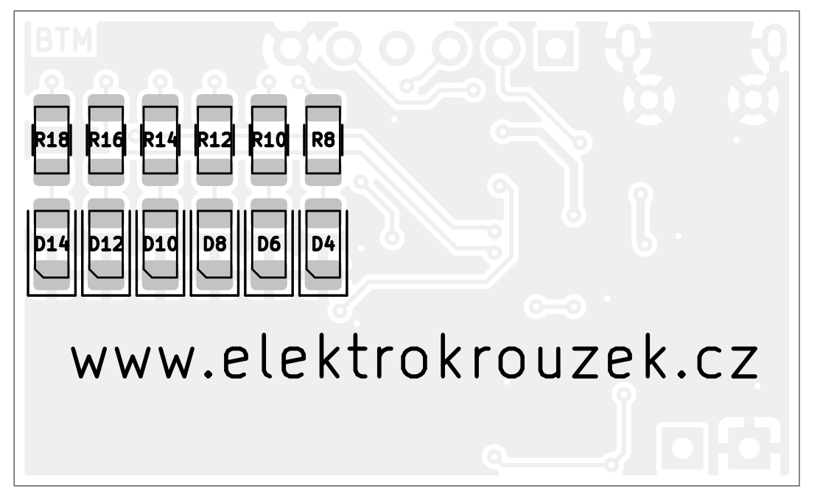

Schematic
